A Guide to the Balkan Wars
And
The Armies involved

Compiled
By
Peter of
Tiger Minatures

The Balkan wars of 1912 and 1913 occurred due to the Weakening of the Ottoman Empire; which had just lost the Italian- Turkish war in North Africa. and the determination of the new Balkan Alliance or League to resolve their issues of National unity.

The first Balkan War hostilities started in earnest in October 1912

The First Balkan War

The war was practically four different wars fought against the same enemy in the same region and at the same time.
Turkish hopes to transfer an army from Syria to the Balkans were abandoned due to Greek naval strength and operations in the area.
The Turks had to rely on troops already in the area and began to raise their forces, but had to raise a formation known as the Army of Axios, to make up numbers; this proved to be of poor quality.
Montenegro was the first member of the league to declared war on 5th October 1912. The official start of the war was the 17 October 1912 the same day the Bulgarian Army Crossed the border and attacked Eastern Thrace.
The conflict can be divided up into areas or ‘theatres’ for ease.

Thracian Theatre

On 17th October 1912 Bulgarian forces crossed the frontier and went on the offencive. The Turkish army was not fully ready; even so on 21st October the Turkish war ministry ordered an offensive strike from around Adrianople. The Turkish Army struck out and clashed with the Bulgarian Army around Lozengrad.

The Battle of Lozengrad started on the afternoon of 22nd October and lasted 3 days along a 36 mile front between the City of Adrianople and the fortress of Lozengrad.
Bulgarian 1st Army faced the main Turkish offensive, the Ottoman Thracian Army plus units moving north from Adrianople, and bore the brunt of the fighting. The Bulgarian 1st Army managed to throw back the Turkish attacks on its right flank and held along the whole front. Heavy fighting continued most of the day with the Turkish Forces falling back, re-grouping and attacking again.
The Bulgarian 3rd Army on the Bulgarian left flank easily dealt with an attempt by the Turks to out flank them.
The Turkish army ended the day back where they started.

On 23rd October The Turkish forces abandoned the fortress of Lozengrad and took flight. However it was only after the Bulgarians sent a cavalry patrol towards the fortress on 24th October to see why the Turkish artillery was not firing, that they discovered that the Turks were gone.
The Bulgarian force caught up with the Turkish Forces and charged many times with cry’s of ‘’Na nozh’’ [by the knife] and Turkish forces replied with ‘’Allah Allah’’ but after fierce fighting the Bulgarians gained the upper hand and by 24th October the Turkish forces were in full retreat.

After the battle Bulgarian forces chose to rest for three days instead of pursuing the Turks. Left alone the Turkish force was able to bring up re-enforcements from Constantinople and set up a defensive line between Lyule Burgas and Buni Hisar on a ridge with trenches and close artillery support.

On the 27th October the Bulgarian 3rd Army set off after the Turkish Army. The Bulgarian 1st Army followed later.
The Turkish forces now divided into 1st Army with 1st and 4th corps around Lyule and 2nd Army with 2nd, 3rd, and 17th reserve corps around Buni Hisar

The Battle of Lyule Burgas started on 28th October with a skirmish in the Village of Kolibi Karagach. Here the Turkish forces fought well and the Bulgarians were held off.
On the 29th October Bulgarian 3rd Army attacked frontally along the whole line but could not break the Turkish defences.
Bulgarian 1st Army arrived on 30th October held upon the way by terrible rain.
Heavy artillery exchanges from both sides continued through out the battle; this helped the Turkish forces to force back the Bulgarians attacks. However failings in the supply of artillery shells to the Turkish guns now caused a slackening of fire and when the Bulgarians re-grouped and renewed their attacks, they threw everything in, even using night attacks with search lights.

On 31st October after three days of attacks and counter attacks by both sides the Turkish left flank gave way, the Bulgarian forces in the Centre broke into the line and Bulgarian 3rd Army out flanked the Turkish Right. Unable to match the Bulgarian Artillery fire the Turks gave way and fell back.
However the Bulgarians again delayed in their follow up allowing the Turks to retreat unmolested. The Turkish army turned again to face the Bulgarians and set up a defensive along the Chtaldzha line 20 miles from Constantinople. They held here and waited, it wasn’t until 17th November that the Bulgarians attacked, after a day of heavy fighting the Bulgarian forces were thrown back and the attacks were eventually called off.
Both sides were now suffering from exhaustion and disease; cholera had broken out.

Around Adrianople Bulgarian forces took up position and made siege to the city.

Western Theatre

On 15th October 1912 the Serbian 3rd Army repulsed attacks from Albanian irregulars and on the 20th October crossed the frontier. Dealing with Turkish frontier troops and fighting a stiff action in the Teneshdol Pass they advanced to Kosovo and occupied it.
Leaving a small garrison they move south to Skoplje. Albanian irregulars opposed them at every turn, harassing the garrison troops and the advancing army.
On 17th November these Serbian forces made contact and joined with Montenegro forces besieging Scutari.

Meanwhile on the 19th October Serbian 1st army crossed the frontier and attacked south toward Skopje and Monistir.

The battle of Kumanova. Serbian 1st Army ran into a large Turkish force, the Vardar Army, north west of the town of Kumanova although only half the size of the Serbian force the Turks were ordered to attack and on the 23rd October they moved against the Serbian right flank, fighting spread along a 10 mile front. In the heavy rain the Turks took advantage of their initial advantage of numbers at the attack points, but, as more Serbian forces arrived to join the battle the tide slowly began to turn against them. On 24th October Serbian counter attacks grew and both sides were involved in heavy frontal fighting. More and more Serbian artillery began to arrive and overwhelm the Turkish Batteries. Serbian Infantry attacked across open ground under cover of their artillery and broke into the Turkish lines, by the afternoon Turkish forces were falling back, it was over.

Bad weather hampered the Serbian 1st Armies pursuit of the fleeing Turks and on 24th October units of the Serbian Morava Division came under fire north of Prelep.

The Battle of Prelep
On 24th October more Serbian troops had arrived and the Turkish forces were withdrawn a little way south.
On the 25th October the Serbians advanced south and again came under fire from Turkish troops. The Turks controlled the high ground and had set up good defensive positions. The Serbian forces openly ordered themselves to attack, they formed up and organised for the attack in full view of the waiting Turks. Unfortunately the Turks had abandoned their artillery in the retreat and so had to watch and await the attacks. On 26th October Serbian forces made repeated attacks on the defences. Using Bayonets and hand Grenades the fighting was hand to hand, the Serbs suffered heavy casualties, mainly due to their open infantry attacks, [the same tactics caused huge casualties 3 years later in world war one]. Finally the Turks gave up the field and headed for Bitola [Monistir]
The Serbian Forces now converged on Bitola.

The Battle of Bitola
An artillery exchange opened the events at Bitola on 16th November followed by Serbian Infantry advances against the Turkish positions. Mud, rain and Turkish Artillery fire held off the Serbian attacks, on the 17th November Serbian Infantry took the Oblakov Heights and on the 18th November Serbian Artillery began to arrive in force, Serbian Heavy artillery came into action against Turkish gun positions, knocking them out one by one. Serbian Infantry were now able to break into the Turkish left flank and the Vardar army collapsed and turned into a disorganised retreat.
Among the Turkish dead was 7th Corp commander Feti Pasha, he was the highest ranking officer to die in battle in the Balkan wars.
The Turkish forces left Macedonia and sought refuge in Southern Albania.

Montenegro

Montenegro was the first member of the Balkan league to act against the Turks and declared war on the 8th October. The day after Montenegro sent the Zeta Division across the border, fighting its way to Scutari along the eastern side of Lake Scutari, it faced Turkish resistance all the way. It also sent the Coastal Division along the western side to attack the Turkish defences West of Scutari. The Montenegro forces began to besiege the town.
Attempts to ‘Rush’ the defences failed and the siege dragged on, even after Serbian forces joined them on 18th November, the town held out until the end of the war.

Montenegro forces had limited success elsewhere.

The Army of Thessaly

On 18th October 1912 the Greek army crossed the frontier in two columns and headed for Selonika. This caught the Turkish forces out as they had concentrated elsewhere.
The first engagement took place at the Sarantaporos Pass.
The Battle of Sarantaporos started on 22nd October in heavy rain; Greek forces attacked the Turkish army drawn up in defensive positions in the Sarantopos pass. Greek forces made a frontal charge and after heavy and heroic fighting by both armies the Greeks broke through the defences.
Turkish forces fled abandoning stores and equipment. Greek pursuit was slowed by the weather and exhaustion.
On the 1st November Greek forces again engaged the Turks at Yanitsa. In a bloody battle the Turkish defenders threw the Greeks attackers back. But on 2nd November Greek troops attacked again and after some close fighting over ran the Turkish Position.
The Turkish forces withdrew and the Greeks continued their advance on Salonika. To cover this advance the Greek army sent a force north, the Greek 5th Division. They met a large Turkish force at Klidion.

The Battle of Klidion
On the 5th November a Turkish force from the Vardar Army strengthened by irregular troops attacked the advancing Greek force, after a two day bloody fight the Greeks had to fall back in disorder. But they fell back only to reorganise and advance again.

The fall of Salonika.
Greek forces advanced on Salonika; however on the 7th November Turkish leaders entered into negotiations for the surrender of the town and agreed terms on the 8th. The Greeks took control of Salonika and crown prince Constantine then ordered additional forces north.
Reorganised and rested the 5th division attacked and pushed back Turkish forces, it captured the Town of Florina on 20th November.
Turkish forces withdrew into Albania, after reorganising the Greeks resumed their advance crossing into Albania on 20th December.

In Salonika the Bulgarian 7th Rila division arrived on the 9th November and occupied areas of the town. An uneasy joint occupation now existed between the allied forces.

The Army of Epirus

The Greek army of Epirus crossed the border on 19th October moving northwest it occupied the town of Philippias on the 26th October. Dividing the force one part moved to Preveza and laid siege to the old fortifications, which held out until the Turks surrendered on 4th November.

The second force headed north where Greek forces encountered heavy resistance, this slowed their advance. After the surrender of Preveza on the 4th November Greek forces were reinforced with a volunteer corps under the command of Italian General Ricciotti Garibaldi, son of the famous General Garibaldi. Strong resistance meant that the Greeks didn’t arrive to lay siege to the city of Janina until 25th November. Reinforced by volunteers and irregulars from Crete and Greece the Greek army faced a heavily fortified city; which itself had been reinforced with Albanian irregulars and Turkish troops retreating from Macedonia.
Despite skirmishes and assaults the defenders held out and the siege continued until the end of the wars.

Meanwhile the Greek navy rapidly occupied the Aegean islands still under Turkish rule.
Following the declaration of war the Turkish Navy did not dare exit the safety of the Dardanelles and spent most of the war in Nagaras. The Greek navy liberated the Islands of the Aegean from Turkish rule without interference.

The war was ended with the Treaty of London in May 1913.
The Forces Involved

Turkey / Ottoman Empire

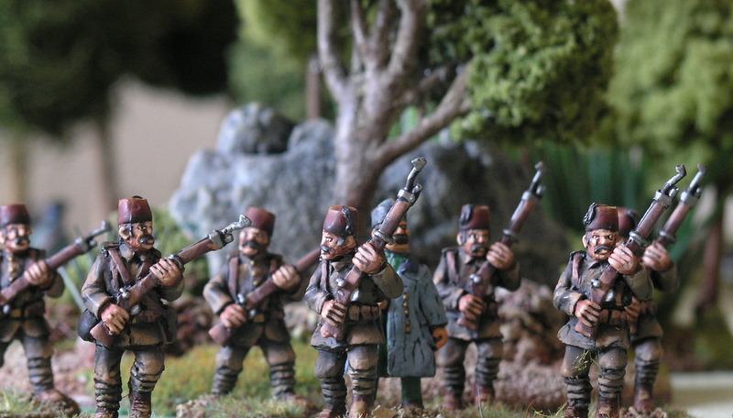
Regular Turkish Infantry

Turkish Infantry Division made up of Anatolian Turks.

3 Brigades of Infantry

A Brigade had 3 battalions of Infantry of 800 men and a Machine Gun Company of 4 Machine guns

A Battalion had 4 companies of 200 men.
A company had 4 platoons of 50 men.
A platoon has 4 sections of 15 men.

Artillery Brigade of 24 guns in 2 Battalion each of 3 Battery’s of 4 guns.

Support – Marksman Battalion, 1 squadron of mounted Infantry, a Pioneer Company and a Telegraph company.

Troop Types

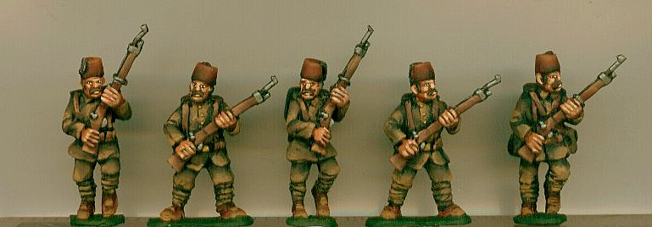
Turkish Infantry in 1908 uniform

Regular [Nizam] Infantry 1909 Field Uniform

Khaki coloured fez but some older red fez with tassels was still in use. The standard uniform was now khaki; a jacket and trousers that were wider at the top and tapered to the knee, puttees and leather boots.
The equipment belt was leather and in the German style with six cartridge boxes. A haversack, a backpack with folded ground sheet and a tin basin attached [used for washing before prayer].
Rifle was the 7.65mm Mauser Magazine Rifle 1903 model.
Reddiff or reserve Infantry

These were issued the new uniform but as with most armies it was slowly being introduced so many units still wore an older style brown or even blue uniform with a small red fez.
Equipment belts and straps were black
They were armed with an earlier 1890 mauser rifle
Cavalry
Very similar to the infantry with a small fez, later replaced with the typical Turkish ‘Kabalak’ helmet, well recognized as the standard Turkish head wear of WWI.
Cavalry wore tall boots with spurs.
Equipment was a leather officer’s belt with an automatic pistol, carbine and m1889 sabre.

Artillery

Same uniform as regular infantry.
Weapon was the Krupp 75mm Field gun m1896, plus some improved 1908 and 1910 models.
Irregulars

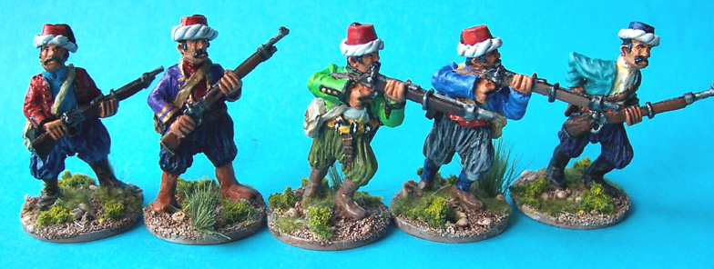
Turkish Irregular Bashi Bazok
Weapons

Turkey was supplied from various European countries and so had a problem with Standardization.
Standard rifle was one of three models of Rifle –a Mauser Rifle 7.65mm or 9.5mm or the Henri-Martini.
Artillery was mainly Krupp 7.5mm guns
The Ottoman or Turkish forces had five airplanes at the start of the war, but none were in flying order.

Bulgaria

Bulgarian Infantry division

The Bulgarian army was well trained.

2 or 3 Brigades of Infantry.

A Brigade has 2 Regiments of Infantry.
Each regiment has 4280 men and a Machine gun company of 4 machine guns

A Regiment has 4 Battalions of 1000 men.
A Battalion has 4 Company’s of 250 men.
A Company has 4 platoons of 60 men.
A Platoon has 4 Sections of 15 men.

Artillery Brigade with 2 regiments of Guns
One of 3 Battalions of 12 Quick firing guns Divided in 3 battery’s of 4 guns.
One of 2 Battalions of 18 Non Quick fire guns [older] in 3 battery’s of 6 guns.

Support – Gendarmerie Squadron, Pioneer Battalion, Bridge Train and medics.

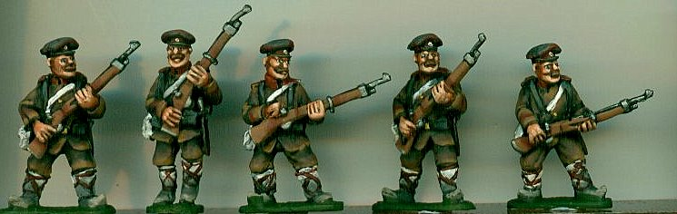
Bulgarian Infantry

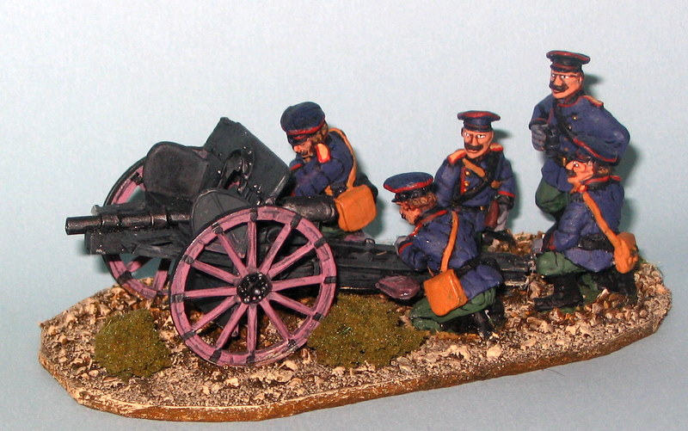
Bulgarian Gun Crew in Action

Weapons

Standard rifle / carbine was the 6.5mm Magazine type Mannlicher magazine rifle with a short bayonet, with a few 1907 upgrades.
Machine guns were mainly 8mm Maxims.
Artillery was mainly Schneider-Creusot and the Schneider-Cannet 75mm Quick Fire Field gun from Crezot factory M1897. plus older 8.7cm Krupp guns, 7.5 mm Krupp mountain guns.
The Bulgarians also had 5 Airplanes at the start of the war.
Greece

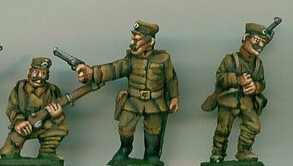
Greek Infantry

Greek infantry Division

3 Infantry Battalions

A Battalion of 1080 men in 4 companies
A company of 250 men in 4 Platoons of 60 men.
A platoon has 4 sections of 15 men.

Artillery Brigade has 24 guns in 2 battalions of 12 guns in 3 batteries of 4 guns.

Support – 2 Evzone [elite unit, trained light infantry] Battalions. 1 Squadron of Cavalry. Pioneer Company and Medical Company.

Uniforms

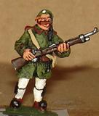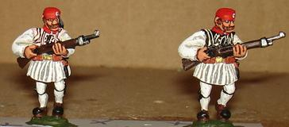
Evzone

Evzones [shooters]:- Elite troops

Paintings, photographs and eye witness accounts suggest that a mix of traditional uniform and the newer 1908 style uniforms were worn during the campaign.
‘’ some privates and NCOs’ preferred the traditional uniform and ignored the regulations’’
Main parts of the Evzone uniform.
The hat[farizan] made of red baize with a silk tassel
The shirt white with wide sleeves
The waist coat [doulamas] which was hand embroidered in a traditional style
The kilt [foustanella], 30m of white material with 400 pleats
White woolen leggings with garters around the knee
A cartridge belt
Tsarouhai – hand made shoes in red leather with a black pompom at the toe.

Cretan Gendarmerie

Mainly used as Military Police during the campaign; but accounts show that they did get themselves into front line actions.
A traditional uniform of dark blue with a red beret or fir cap. The trousers are very baggy with lots of folds around the waist / upper legs and short boots.

Greek infantry / artillery

A standard Khaki uniform [with a shade of olive green], Soldiers wore a peaked cap, a tunic [similar to the 1902 British style] and long trousers in the standard khaki colour. Puttees were often used and soon became regulation.
Equipment belts were leather with 3 cartridge boxes and shoulder straps, a haversack and canteen.

Greek Cavalry
As for the infantry, but with brown riding boots and khaki riding breeches.
Equipment was leather ammunition belt with cartridge boxes similar in style as Germany.

Weapons
Standard rifle / carbine was the 6.5mm Magazine type Manlicher – Shouhauer 1903 model, with a few 1907 upgrades.
Artillery was mainly Schneider-Creusot and the lighter Schneider-Cannet 75mm Quick Fire Field guns from Crezot factory M1897.
The Greek Army has Four Airplanes at the start of the war.
Montenegro

Montenegro Infantry Division.

Behind other members of the League in Military training and equipment.
It was mainly an organised Militia made up of most males in the country. They did however have recent battle experience due to clashes along its border with the Ottoman empire. This created some seasoned veteran individual soldiers, but not an army.

3 Brigades of Infantry.

A Brigade of 6 or 7 Battalions [ 2 of 1st Ban, 2 of 2nd Ban and 2 of 3rd Ban]. with a machine gun company of 4 machine guns.
Each Battalion had 400 to 800 men.

Artillery support – 1 Battery of 4 Quick fire Guns and 2 or 3 Batteries of Quick fire Mountain Guns.

Support – Telegraph and Pioneer Detachments and a 50 Mounted Secret service section.

The three Bans of infantry were
- Levy of 18 and 19 year olds serving for two years.
- Active army – from 20 to 52 years olds, called up annually for 18 days training.
- Reserve, all men between 53 and 62 years of age.

All Men are Trained Light infantry and mountaineers.

Cavalry – they had a small cavalry force – 1 officer and 30 men in total.

Weapons
Standard rifles were a variety of Russian Berdan and other rifles.
Artillery was a mix of light and mountain Artillery mainly of Italian or Russian origin.

Serbia

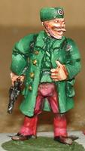
Serbian officer

Serbian Infantry Division.

1st Ban Division

4 Brigades of Infantry

A Brigade had 4 Battalions and a Machine Gun Section of 4 machine guns.

A Battalion had 4 companies of 260 men
A Company had 4 Platoons of 60 men.
A Platoon of 4 Sections of 15 men.

A Cavalry Brigade of 3 Squadrons.

An Artillery Brigade of 3 Battalions each of 3 Battery’s of 4 Guns.

Support – ½ Pioneer Battalion, Bridge Train, Signals section and Medical services.

Serbian Reserve Division.

3 Brigades each of 2 X 2nd Ban light Infantry battalions, 3X Landsturm Battalions and 2 X 3rd Ban Infantry. Supported as above 1st Ban Division, with an Irregular Infantry unit.

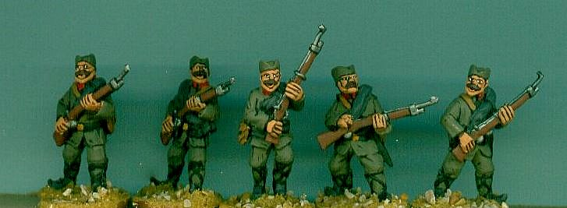
Serbian regular Infantry

Weapons
The Standard rifle was the 1889 Mauser Model Rifle.
In the Serbian Army every Infantry Regiment had a Machine gun Section, these were 7mm Maxim Machine guns
Artillery was mainly 7.5mm Schneider-Creusot and some older ordinance.
At the outbreak of war the Serbian army has three airplanes.

Scenarios

Scenario – 1

Bulgarian Forces Attack Greek Village and defence Line

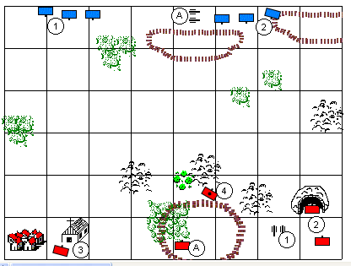

Bulgarian Troops [Blue] :- Attackers

3 Units of regular Infantry. [1 Elite] each 15 men strong
2 Units of Irregular Infantry and 1 Regular Unit each 15 men strong
A Support 1 Quick Fire Artillery Piece. Can be place anywhere on base line.

Greek Troops [ Red]

Support Artillery 1 Quick Fire Field Piece.
2 Regular Infantry units [one in Field works] each 15 men strong
Village occupied by 1 unit of Cretan Gendarme. 10 men strong.
1 concealed Machine Gun behind low wall. 1 M/G with two crew.
A 1 Unit of Elite Evzones 15 Men strong [elite]

What Happened in our Game?
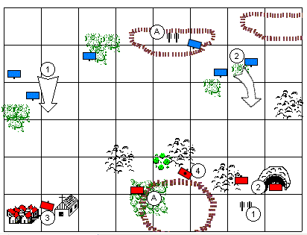
Bulgarian Forces attacked on two fronts with artillery support concentrated on the Greek Right wing.

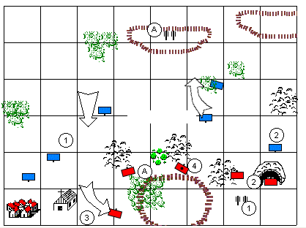

Bulgarian forces take the Village but the Greek forces fall back and reform.
While the Greek right wing throws back the Bulgarian Attackers.
Bulgarian Artillery [with the luck of the dice] Silence the Greek Guns and turn on the Machine gunners.
With the village lost and their flank compromised and with out Artillery support the Greek forces decided to make a tactical withdrawal.

Scenario- 2

